Cross Resource Attribute Reference:
How to call a dependent value from one resource to another resource?
Assume you have an elastic IP which we need to configure in SG. For that first we need to create IP and then we need to config it. But, If you need call the value to another resource you don’t know the exact IP during writing stage of TF file. So to call this IP to another resource we have to specify the attribute. This attribute will call the IP.
Basics of Attributes:
Each resource has its associated set of attributes.
Attributes are the fields in a resource that hold the values that end up in state.
Eg of attributes: ID of instance,public-ip,private_ip,private_dns etc.
The values of attributes which we mentioned above will appear when it’s created. So during creation stage of TF file you are not aware about those attributes. For that we will just call the attribute that is public_ip it will call the public of that instance.
For ref pls find the link: aws_instance | Resources | hashicorp/aws | Terraform | Terraform Registry
Hands on of attributes:
Create a file name with ‘reference-attributes.tf’ and the below content. In the below content we are going to call IP to SG. It will create a SG with inbound rule with elastic IP.
For that first we will collect the resource script of elastic ip by searching aws_elastic_ip you will get a script collect it and copy it like below and remove unwanted. Here lb is the name.
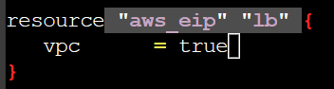
Now we will add the SG script by searching aws_security_group.
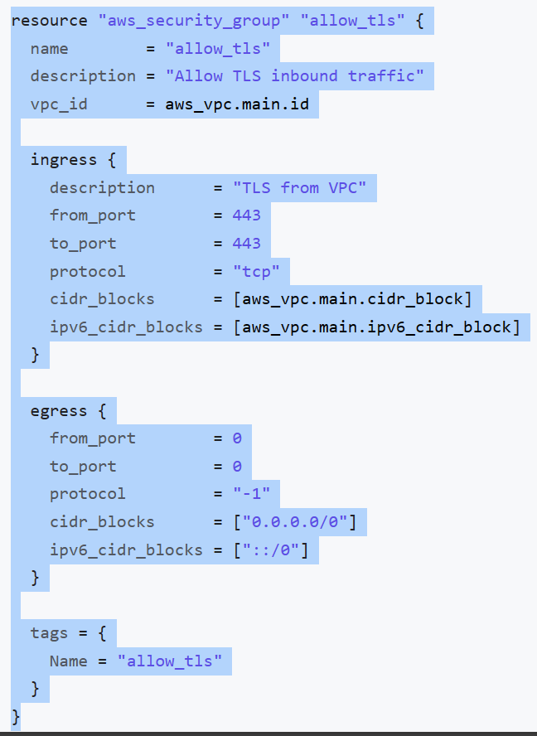

Now make changes to the security group to cidr_blocks = [aws_eip.lb.public_ip]
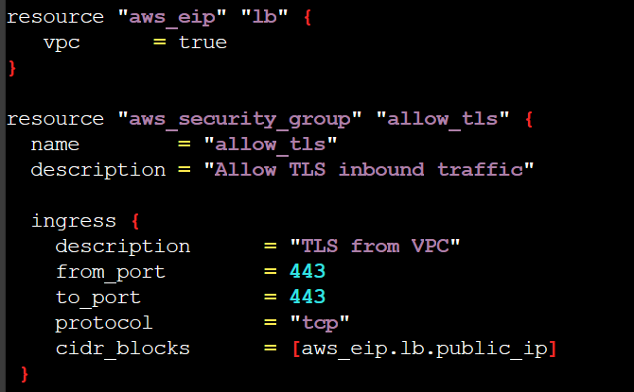
Here aws_eip is the module of elastic ip, lb is name of the module & public_ip is the attribute which we get from TF documentation.
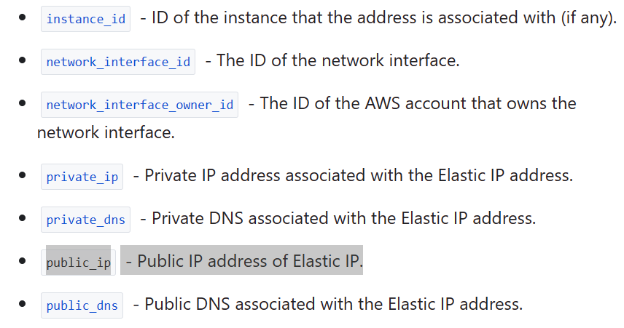
Above script will not create the SG because we need to add CIDR block that is /32. To define that in the script need to mention like below.
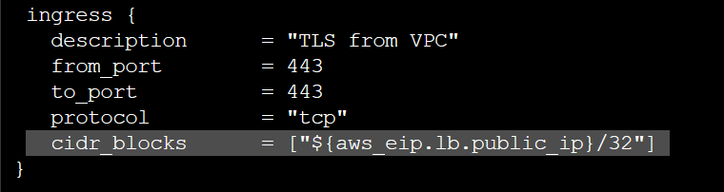
Now it will create a SG with the Elastic IP.
The whole script will look like this.
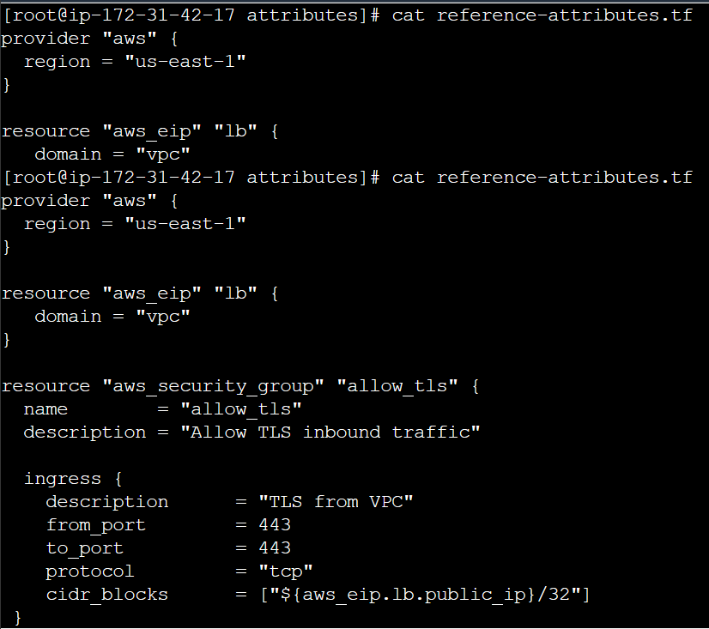
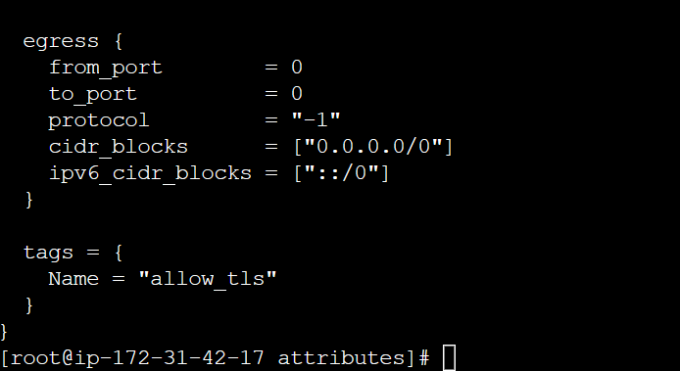
Output Values: Print info about your infra values available on the command line while execution, and can expose info for other TF configs to use.
Eg: If you write a script to create an EC2 instance after running the script if you want to collect the IP of it you need to go to AWS console.But with the help of this you can collect the output values after executing the script itself.
Now make following change in the script.
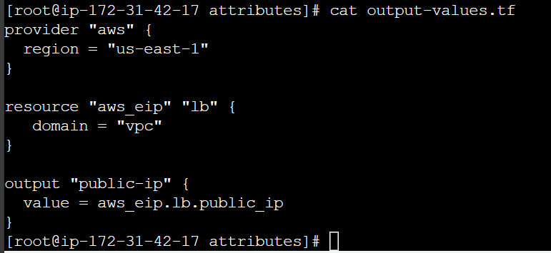
Here we call the variable name (public-ip) with output module and the value is aws_ip.lb.public.ip.
And output of the above script would be.
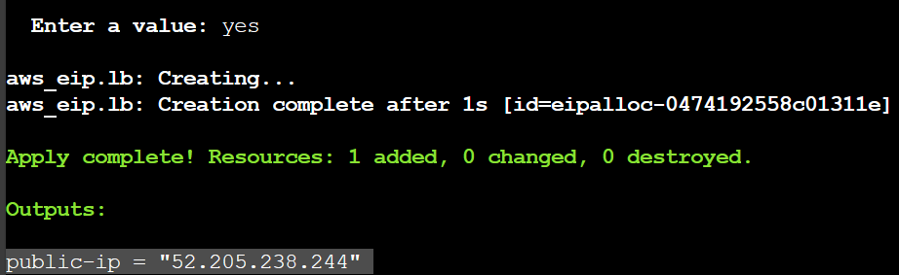
Output value defined in Project A can be referenced from code in Project B with help of Project A state file.
Terraform Variables:
Create a file with variables.tf and add below script.
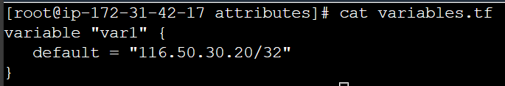
Here variable is module, var1 is variable name and default is the value that is IP.
Here we are going to add inbound rule to 3 ports they are 53, 80 & 443 for that our TF script for SG will look like this.
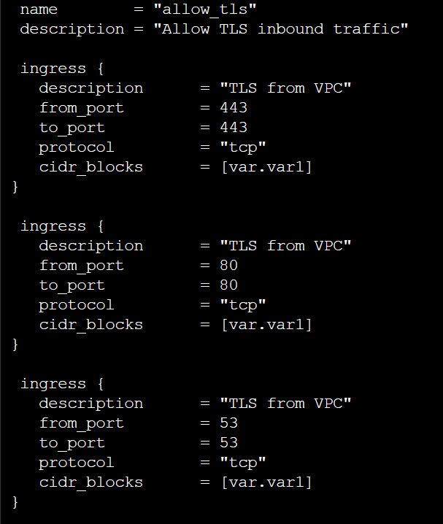
We need to specify our variable in cidr_blocks = [var.var1]. here var is mandatory to mention for calling a variable and var1 is variable name.
Output:
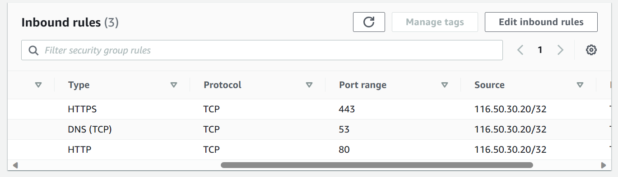

Approaches for Variable Assignments:
Variable in Terraform can be assigned values in multiple ways.
- Environment variables
- Command Line Flags
- From a File
- Variable Defaults
To demonstrate this we are going to create ec2 instance by using different variable methods.
Variable Defaults:
This one looks like this.
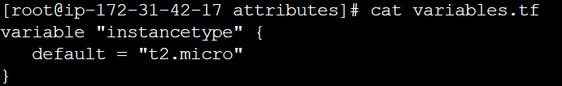
And ec2 creation script looks like this.
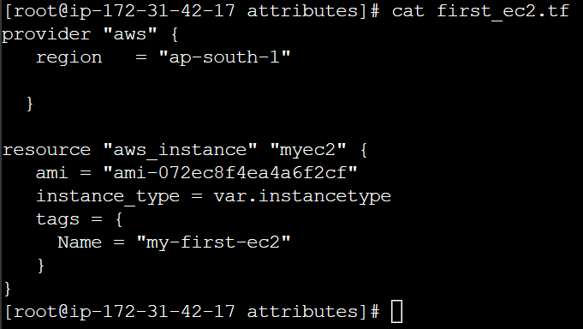
From above script we will create t2.micro ec2 instance.
Command Line Flags:
To provide variable, we will provide it through command. Here I’m using terraform plan to avoid unnecessary creation of services
The above command will create an ec2 instance with t2.small. PFB output.
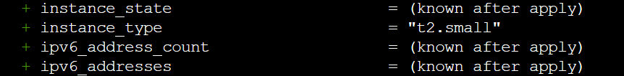

From a File: Here we will use a file to store variables. The file name should be default that is terraform.tfvars
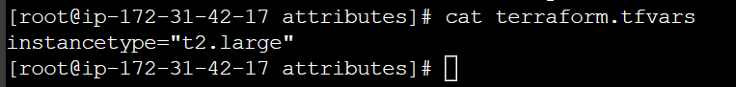

And output will be.
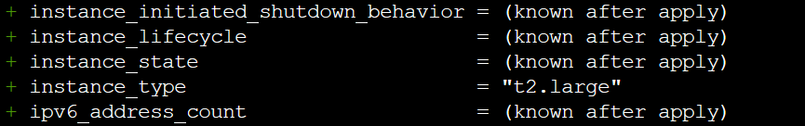
To mention the custom variable file you need to mention like this.
Environment variables:
Use below command. Not working need to check (I think need to set globally)
export TF_VAR_instancetype="t2.nano"
After running above command run terraform plan.
Data types for variables:
Data type for variables is when you set a variable with particular set like string/numeric it will look for such date type only.
Eg: If you specify the type number if you give a alphabet it won’t take it will throw an error.
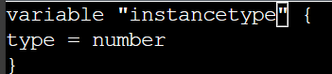
From above script type = number when you run the script when you enter string type it will throw an error because it was expecting number.
Type Keywords | Description
String | Sequence of Unicode characters representing some text, like “hello”
List | Sequential line of values identified by their position. Starts with 0  [“mumbai”, ”singapore”, “usa”]
map | A group of values identified by named labels, like {name = “Mabel”, age = 52}
number | Example: 200

Eg:-
Here I’m creating ELB with dummy script even though that is not exact script to create ELB but for understanding I took this as example.
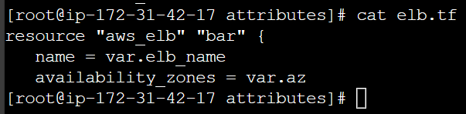
And variable file will look like with data type
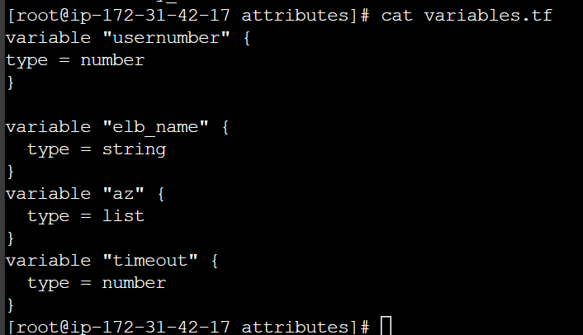
And terraform.tfvars file looks like this.
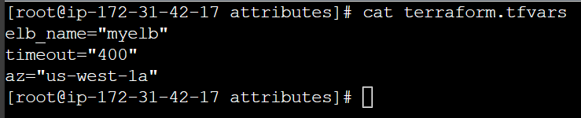
In the above file, you can add more AZs along with us-west-1a like this
az=[“us-west-1a”, “us-west-1b”]
How to call one variable to another variable(Fetching data from Maps and list in variable):
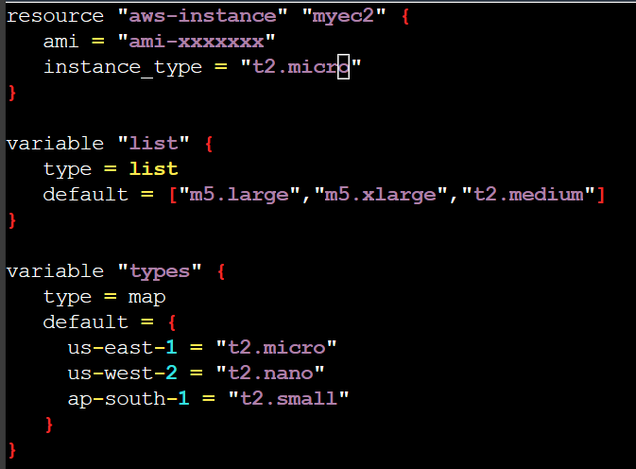
Above script is the initial script, In that script we will make changes to call variable from another variable like below. The below script will create a t2.nano cause it’s calling us-west-2 variable
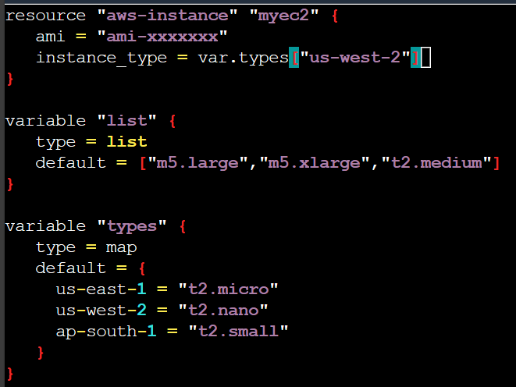
Like wise we can call list, but we need to give position of the variable like 0,1 &2.
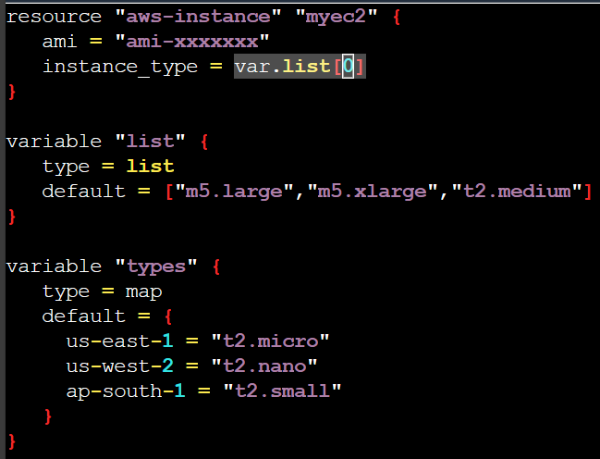
The above script will create m5.large ec2 instance because we specified 0 position in list.
Count and Count Index:
Overview of Count Parameter:- The count parameter on resources can simplify config and let you scale resources by simply incrementing a number.
Let’s assume, you need to create two EC2 instances. One if the common approach is to define two separate resource blocks for aws_instance.
With count parameter, we can simply specify the count value and the resource can be scaled accordingly.
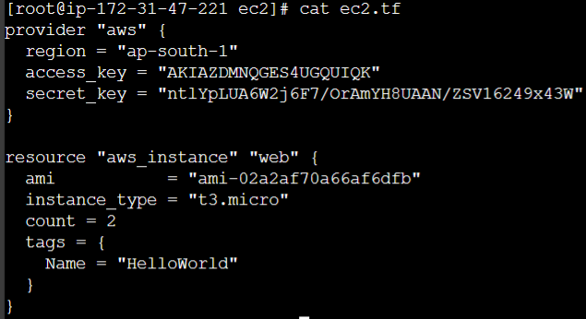
Count index:
In resource blocks where count is set, an additional count object is available in expressions, so you can modify the configs of each instance.
This object has one attribute:
Count.index- the distinct index number (starting with 0) corresponding to this instance.With the below script it will create the ec2 instancce with diff names that is HelloWorld.0,HelloWorld.1 & HelloWorld.2
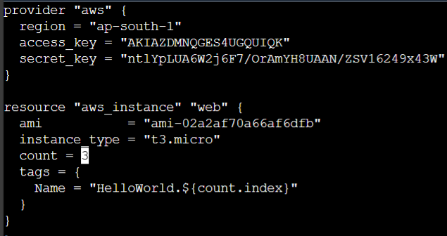
The output is:-
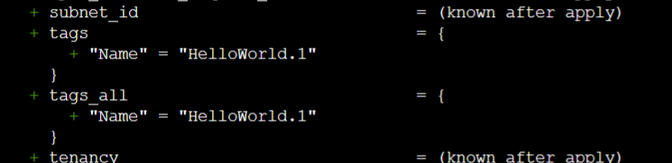
Having a username like HelloWorld.0,HelloWorld.1 & HelloWorld.2 might not always be suitable.
Better names like dev-ec2, stage-ec2, prod-ec2 is better.
Count.index can help in such scenario as well.
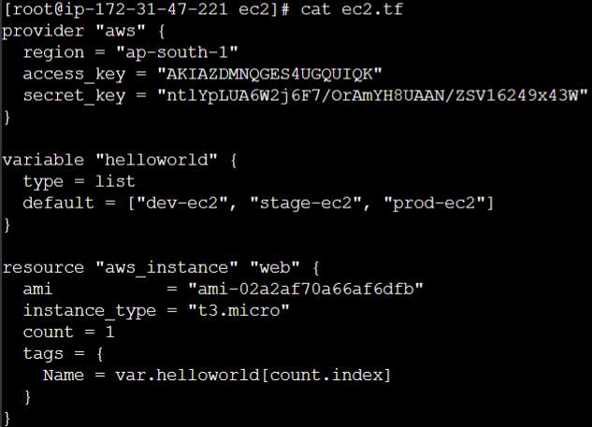
From above script we are changing the names by using variables.
Output:-
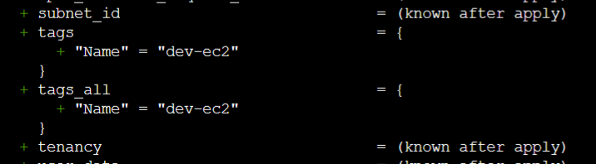
Conditional Expression:-
A conditional expression uses the value of a bool expression to select one of two values.

Syntax of Conditional expression:
condition ? true_val : false-val
If condition is true the result is true_val. If condition is false then the result is false_val.
Let’s assume that there are two resource blocks as part of terraform config.
Depending on the variable value, one of the resource blocks will run.

True Dev
Is-test
False Prod
Variable
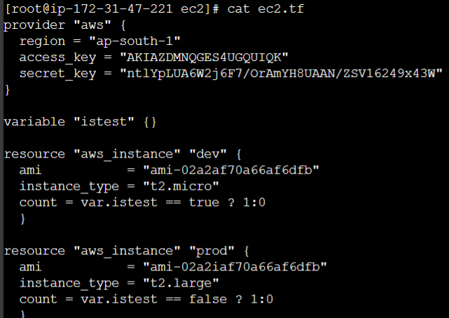
From above script we will create t2.micro if istest is true and it will create t2.large if istest is false.
The expression count = var.istest == true ? 1:0
Here 1:0 is if it’s true it will create 1 instance otherwise 0.
Local values:-
A local value assigns a name to an expression, allowing it to be used multiple times within a module without repeating it.
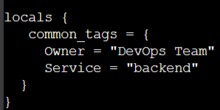
From above image we have defined the tags under locals. From that we will call the tags to all the resources like below.
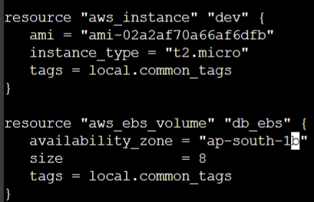
The whole script will look like this.
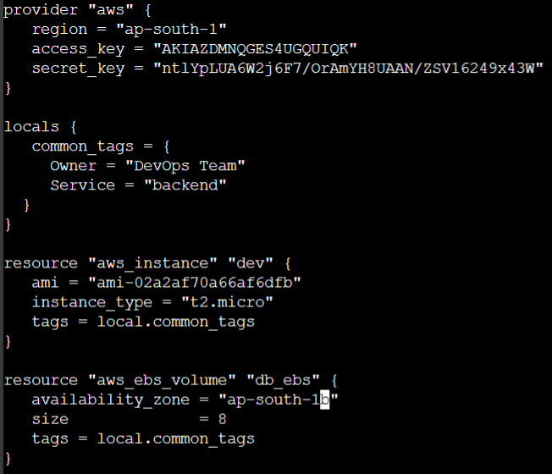
Important pointers for local values:
- Local values can be helpful to avoid repeating the same values or expressions multiple times in a config.
- If overused they can also make a config hard to read by future maintainers by hiding the actual values used.
- Use local values only in moderation, in situations where a single value or result is used in many places and that value is likely to be changed in future.
Terraform Functions:-
(Need to see)
The terraform language includes a number of built-in fucntions that you can use to transform and combine values.
The general syntax for function calls is a function name followed by comma-separated arguments in parentheses:
Function (argument1,argument2)
>max(5,12,9)
12
The terraform language does not support user-defined functions, and so only the functions built in to the language are available for use.
- Numeric
- String
- Collection
- Encoding
- Filesystem
- Date and Time
- Hash and Crypto
- IP Network
- Type Conversion
For more info go here Functions - Configuration Language | Terraform | HashiCorp Developer.

To check above example, we can use terraform console command.
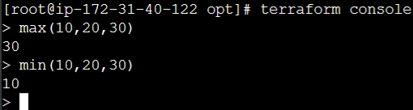
Before writing in the script, First we can test with ‘terraform console’. If the thing goes well we will use in the script.
Good part is the in Terraform site i.e., in above link we have example for each function.
Function used in this video are lookup, element, formatdate and file (It’s almost like a ‘cat’ command).
For more info go to the above document. Please try the above mentioned functions from functions.md file. It will be confusing but it will be easy.
Data sources:-
Data sources allowed data to be fetched or computed for use from elsewhere in terraform config.
Let’s say if you want to launch an instance in different regions for that we need that particular region’s AMI ID. So AMI ID may differ region to region. In that case how to define in .tf file generically.So, Data source will help us here.
- Defined under the data bloack
- Reads from a specific data source (aws_ami) and exports results under “app_ami”.
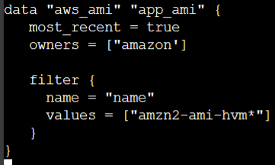
From above image we are getting most recent image and owner will be Amazon, here if the owner will be windows or some other and filter will amzn2 may change accordingly. The value in filter need to check.
And whole script will look like below.
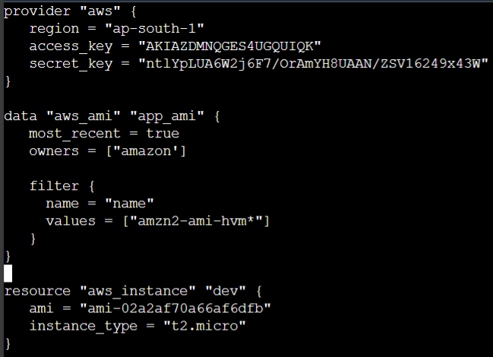
The above script will fetch the AMI from different regions easily.
Note:- To check more about filters in data sources pls go to https://docs.aws.amazon.com/cli/latest/reference/ec2/describe-instances.html
Refer to the - - filters option.
Debugging terraform:-
Terraform has detailed logs which can be enabled by setting the TF_LOG environment variable to any value.
You can set TF_LOG to one of the log levels TRACE, DEBUG, INFO, WARN or ERROR to change the verbosity of logs.
This will provide the more detailed tf logs. Let’s say if you want to see TRACE logs we need to set env variable.
Export TF_LOG=TRACE
By setting above variable it will fetch trace logs by running the terraform plan command
If you want to store this log in a file we need to use.
Export TF_LOG_PATH=/tmp/terraform-crash.log
Then by running the terraform plan command you can see the all the TRACE related logs will be storing in the mentioned path.
Note:-
Trace is the most verbose and it is the default if TF_LOG is set to something other than a log level name.
To persist logged output you can set TF_LOG_PATH in order to force the log to always be appended to a specific file when logging is enabled.
Terraform format:-
To format/align terraform code we need to run “terraform fmt”.
Terraform Validate:-
Terraform validate primarly checks whether a config is syntactically valid.
It can check various aspects including unsupported arguments, undeclared variables and others.
Command: terraform validate
Load Order & Semantics:-
Terraform generally loads all the config files within the directory specified in alphabetical order.
The files loaded must end in either .tf or .tf.json to specify the format that is in use.
Let’s say you have infra folder, inside that folder you have multiple .tf file like ec2.tf, sg.tf and vpc.tf etc., now if your run “terraform apply” it will consider all the files in that folder. It’s not necessary all the configs should in one file even though if you split it into multiple .tf file instead of one big file it will work.
Note:- It’s recommended that whenever if you right a code for production it’s good practice that write the code in different .tf files. Because of this it will be easily traceable if you face any issue.
provider.tf
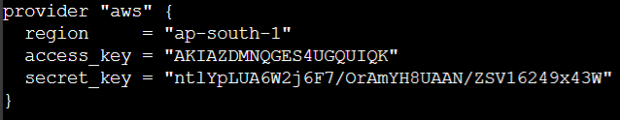
variables.tf
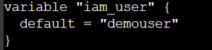
ec2.tf
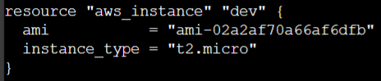
iam_user.tf
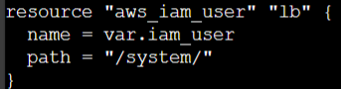
By splitting it, it will be very easy to add something new to the file. Eg:- If you want to add a new user directly we will go to iam_user.tf file and we will add it.
If we have multiple provisions with the same name it won’t work.
Dynamic Block:-
- In many of the use-cases, there are repeatable nested blocks that needs to be defined.
- This can lead to long code and it can be difficult to manage in a longer time.
- Let’s say if you want to config 10 inbound rules it’s difficult to config and that leads to longer code and takes moretime.
Dynamic block allows us to dynamically construct repeatable nested blocks which is supported inside resource, data, provider, and provisioner blocks:
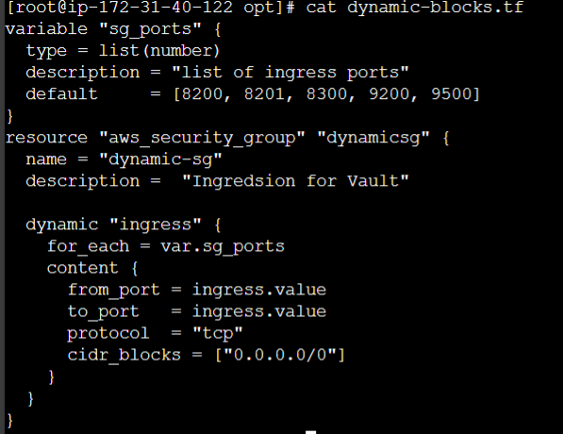
Iterators:
The iterator arg(optional) sets the name of a temporary variable that represents the current element of the complex value.
If omitted, the name of the variable defaults to the label of the dynamic block (“ingress” in the example above).
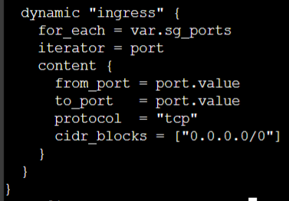
With this easy to read.
Terraform taint:-
- You have created a new resource via terraform. Users have made a lot of manual changes ( both infra and inside the server).These changes are not tracked at the terraform level. So users have made changes so few things are not working.
- Two ways to deal with this: import changes to Terraform or Delete & Recreate the resource.

Recreating the resource:
The “-replace” option with terraform apply to force terraform to replace an object even though there are no config changes that would require it.
Eg:
Terraform apply -replace=”aws_instance.web”
Here in this case “aws_instance.web” is the resource address. Above command will destroy the current ec2 and it will create a new one.
Note:-
Similar kind of functionality was achieved using “terraform taint” command in older version of terraform. For terraform v0.15.2 and later, Hashicorp recommended using the -replace option with terraform apply.
Splat Expression:-
(What is diff between count.index and splat)
Splat expression allows us to get a list of all the attributes.
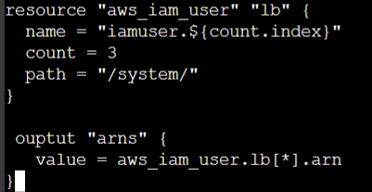
Here splat is [*]. It will create the arn associate with all the user in incremental way 0,1 & 2.
Terraform Graph:-
The “terraform graph” command is used to generate visual representation of either a config or execution plan.
The output of terraform graph is in the DOT format, Which can be easily converted to an image.
Saving Terraform to file:-
The generated terraform plan can be saved to a specific path.
This plan can then be used with terraform apply to be certain that only the changes shown in this plan re applied.
Eg:
terraform plan -out=demopath
The above command will store the terraform plan command output in demopath file, with this you can spin up the services with the help of saved terraform plan file. Which it will create the config stored in the file. To spin up this
terraform apply demopath
Terraform Output:-
The terraform output command is used to extract the value of an output variable from the state file.
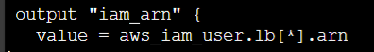
In the above code we have defined the output variable that is “iam_arn”. If you want to check the output of the output of the variable. Run “Terraform output iam_arn”.
Terrafrom settings:-
With this we can set the required version of terraform to be used and provider’s source and version as well.If you are favourite of particular version you can use this command.
ZIPMAP function:-
The zipmap function constructs a map from a list of keys and a corresponding list of values.
List keys list of of values
Pineapple yellow
Orange orange
Strawberry red
Zipmap
Pineapple=yellow
Ornage=orange
Strawberry=red
Eg:
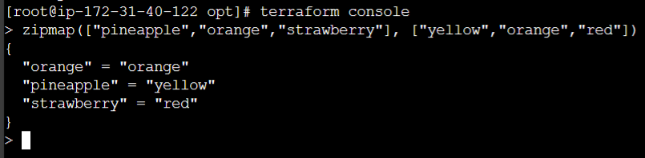
Simple Use-Case:
You are creating multiple IAM users.You need output which contains direct mapping of IAM names and ARNs.
Script:-
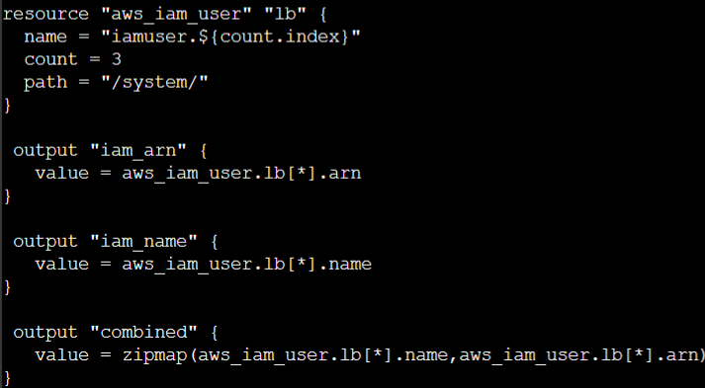
Output:-
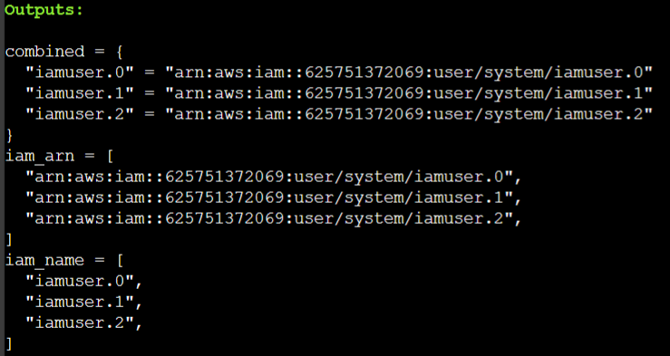
Here, Combined is the output variable which we need to check. It’s capturing the key and value.
Comments inTerraform:-
#,// -> are single line comment
/* … */ -> Multi line comment.
Resource Behaviour and Meta-Argument:-
- Create resources that exist in the config but are not associated with a real infra object in the state.
- Destroy resources that exist in the state but no longer exsit in config.
- Update in-place resources whose arguments have changed.
- Destroy and re-create resources whose argumentrs have changed but which cannot be updated in-place due to remote API limitations.
What happens if we want to change the default behaviour?
Eg: Some modification happened in Real infra object that is not part of terraform but you want to ignore those changes during terraform apply that means you want to keep those changes which made through dashboard.
Let’s say you tagged the Name of the instance as Helloworld later someone has added extra tag that Env is production. If you want to keep those changes and you don’t want to lose it at that situation while doing terraform apply at that case we will use this.
How to change the default behaviour?
Terraform allows us to include meta-argument within the resource block which allows some details of this standard resource behaviour to be customized on a per-resource basis.
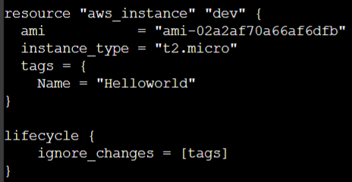
From above script, By adding lifecycle arg we will ignore the changes which happened through the dashboard for only tags.
Different Meta-Arguments:
Meta- Argument
Meta-Argument | Description
depends_on | Handle hidden resource or module dependencies that terraform cannot automatically infer.
count | Accepts a whole number, and create that many instances of the resource
for_each | Accepts a map or a set of strings, and creates an instance for each item in that map or set.
lifcycle | Allow modification of the resource lifecycle.
provider | Specifies which provider config to use for a reference, overriding terraform’s default behaviour of selecting on based on the resource type name

Meta-Argument- Lifecycle:-
Basics of Lifecycle Meta-Argument
Some details of the default resource behaviour can be customized using the special nested lifcycle block within a resource block body.
There are four arg available within lifecycle block
Arguments | Description
Create_before_destroy | New replacement object is created first, and the prior object is destroyed after the replacement is created.
Prevent_destroy | Terraform to reject with an error any plan that would destroy the infra object associated with the resource
Ignore_changes | Ignore certain changes to the live resource that doesnot match the config
Replace_triggered_by | Replaces the resource when any of the referenced items change

Create_before_destroy: By default, when terraform must change a resource argument that cannot be updated in-place due to remote API limitations, Terraform will instead destroy the existing object and then create a new replacement object with the new config arguments.
Let’s say you have created an infra with the AMI initially and later you want to change the AMI of that instance at that time we will config new AMI ID and we will run terraform apply. What it will do is, first it will destroy the existing one and it will create the new one as per the latest AMI ID. But in PROD this down shouldn’t happen, for that we will use create_before_destroy.
The create_before_destroy meta-argument changes this behaviour so that the new replacement object is created first, and the prior object is destroyed after the replacement is created.
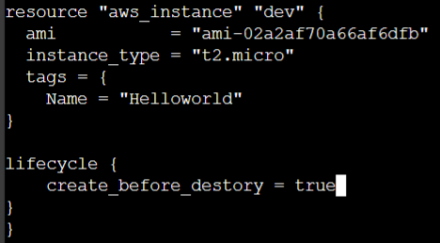
The above code will first create the instance and then remove the old instance.
Prevent Destroy Argument:
This meta-argument, when we set to true, will cause Terraform to reject with an error any plan that would destroy the infra object associated with the resource, as long as the argument present in config.
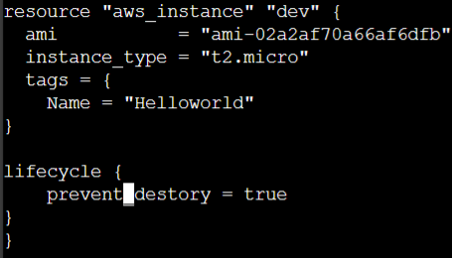
It will not allow to destroy the infra. It will show below while running the “terraform destroy” command.
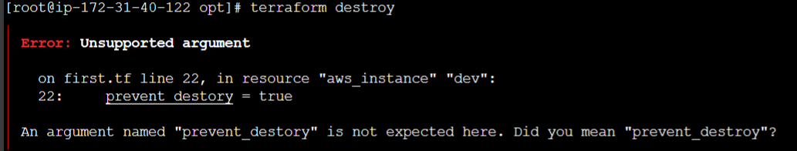
- This can be used as a measure of safety against the accidental replacement of objects that may be costly to reproduce, such as database instances
- Sinc this argument must be present in config for the protection to apply, note that this setting does not prevent the remote object from being destroyed if the resource block were removed form config entirely.
Ignore_changes: In cases where settings of a remote object is modified by processes outside of terraform, the terraform would attempt to “fix” the next run.In order to change this behaviour and ignore the manually applied change, we can make use of ignore_changes argument under lifecycle.
Ealier we have seen how to ignore the changes by adding tags to it. Now we have made a change from t2.micro -> t1.micro so we need to add instance_type then only it will ignore the changes. The code looks like.
lifecycle {
ignore_changes = [tags,instance_type]
}
Note: Instead of a list, the special keyword ‘all’ may be used to instruct terraform to ignore all attributes, which means that TF can create and destroy the remote object but will never propose updates to it.
lifecycle {
ignore_changes = all
}
Data Type-SET:-
Basics of list
- Lists are used to store multiple items in a single variable.
- List items are ordered,changebale and allow duplicate values.
- List items are indexed, the first item ha index[0], the second item has index[1] etc.
Understanding SET
- SET is used to store multiple items in a single variable.
- SET items are unordered and no duplicates allowed.
toset Function
- toset function will convert the list of values to SET.
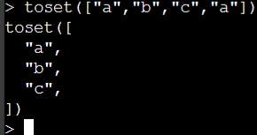
for_each:-
- for-each makes use of map/set as an index value of the created resource.
- If a new element is added, it will not affect the other resources.
resource “aws_iam_user” “iam” {
for_each = toset([“user-0”,”user-01”,”user-02”,”user-03”])
name = each.key
}
Replication count challenge: Count will be used when there is an identical values and we can’t append the value infront of the existed listed value. For replication count challenge, If a new element is added, it will not affect the other resources.
resource “aws_instance” “myec2” {
ami = “ami-1234567890”
for_each = {
key1 = “t2.micro”
key2 = “t2.medium”
}
instance_type = each.value
key_name = each.key
tags = {
name = each.value
}
In blocks where for_each is set, an additional each object is available.
This object has two attributes:
Each object | Description
Each.key | The map key (or set member) corresponding to this instance.
Each.value | The map value corresponding to this instance

